Record of Events at Fort Macarena  
Season Leader: Lucero

# 1st Spring 5501

Well it’s all happening today isn’t it. They (I suppose it is we now) had been starting to make sense for a while now, convincing me that we could work together and they were not really the bad guys that we were told they were. When talking with Baker this morning I decided that I would finally join the Colony, I think we had both know I would for a while now, just a question of when.

Strangely everyone must have viewed it as Fate or Destiny or something because today was the start of a new season and they were deciding who would next lead the colony, being stuck at an impasse I guess they all settled on the new Girl. Not convinced that it is not an elaborate prank / hazing ritual, but who am I to go against everyone’s decision, o wait I am the Leader now that’s who.

Before I had even had much of a chance to decide what I wanted to do I was informed that Pace and Thaler had finished researching Electric Smelting, while that will come in handy it also means that now the pressure is on me to decide the next research direction for the entire colony, talk about the deep end on my first day when I haven’t even had a meal yet.

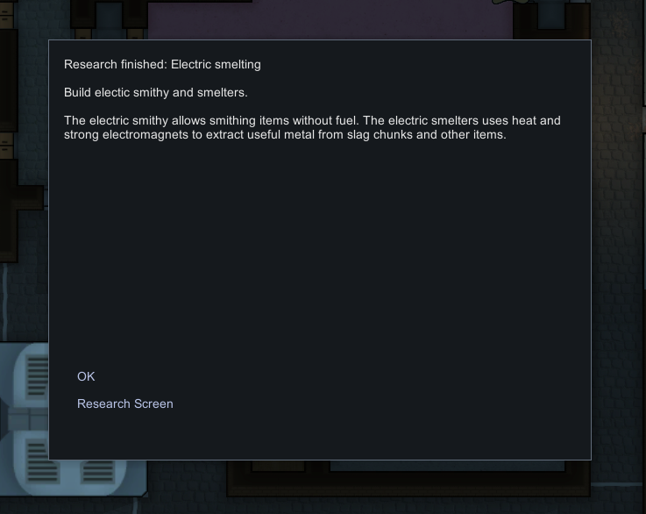

While it is not a nice topic I decided on Cremation technology, once it is done we will be able to stop dumping raiders in a field outside the colony. I might be getting the Multi Analyser next, it looks to lead to some cool looking research.

I then took a little walk to clear my head from being cooped up in that prisoner room for so long. Speaking of my room, I can’t stay there anymore it is for prisoners, and I must have a really good room for myself, and being leader I can make that happen. That will be my first project, having a new room build for me. My new room was not quite finished today, so unfortunately I am settling down in my old room temporarily, but tomorrow will be moving day.

Well I though my day was over, turns out not so much. Our Fine allies of Cooks Kingdom look like they have not been feeding their animals enough so they are malnourished, this would not be out problem usually except for the fact that they are Boomalope that explode when they die and are in our colony. SO rather than resting it is all hands on deck to put out fires. After an Hour we had some rain to help put the fire out.

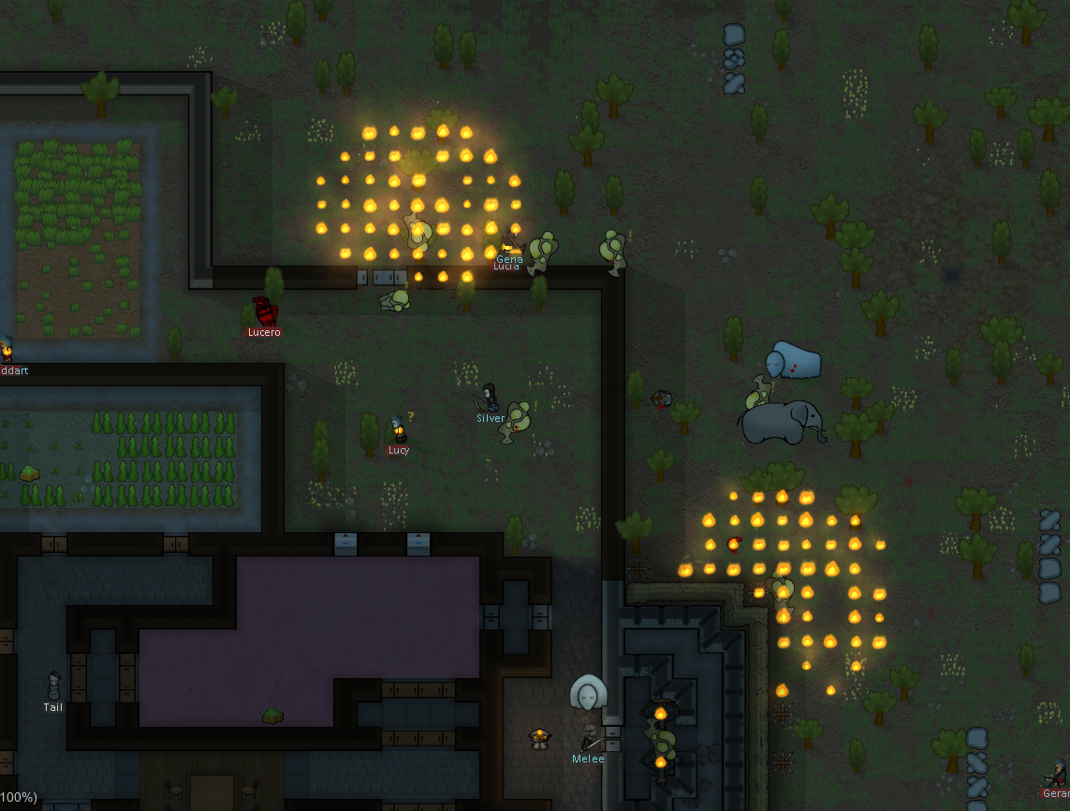

On the bright side my new room has been finished now, here is a picture of it:

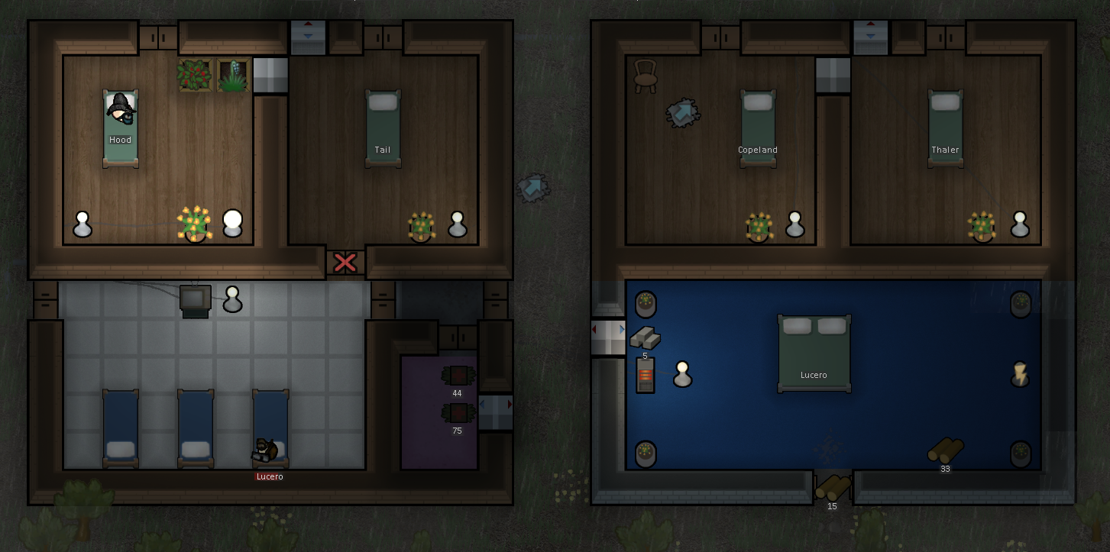

Although you might notice that I am still not sleeping in it, no I am spending tonight in the medical ward recovering from burns I got from the fire, which is ironically located just across from my new room. Wait is that Irony? I always have trouble with that, anyway I am in too much pain and too tired to care right now.

# Day 2

I am still recovering in medical, but as leader (that still has a strange ring to it) I am receiving reports about the aftermath of last night. All the Cooks Kingdom people have left. A scout and a Keeper were killed in the explosions and fires, although fortuitous for us one of them was carrying 700 silver, a boon for the colony and kind of makes up for me getting burnt and all the trouble of putting fires out. At least the Cremation research will be done soon, putting that you use a bit sooner than I would have liked.

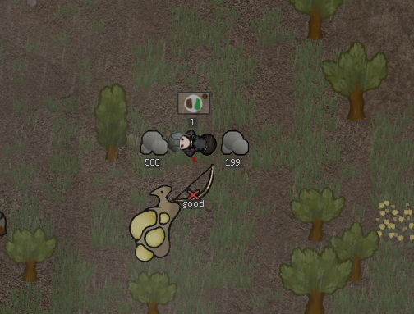

So here I am, starting a New Year and going from being imprisoned to leading the Colony in a single Day. Still not convinced that this isn’t all a prank.

# Day 3

Spent the day chopping up left over Boomalop. Had some people arrive from Priests Kingdom, Luckily they didn’t bring any more Boomalope. Then we had a Boomrat go mad and attack the Colony, luckily it was no match use, I like to think of it as a team building exercise.

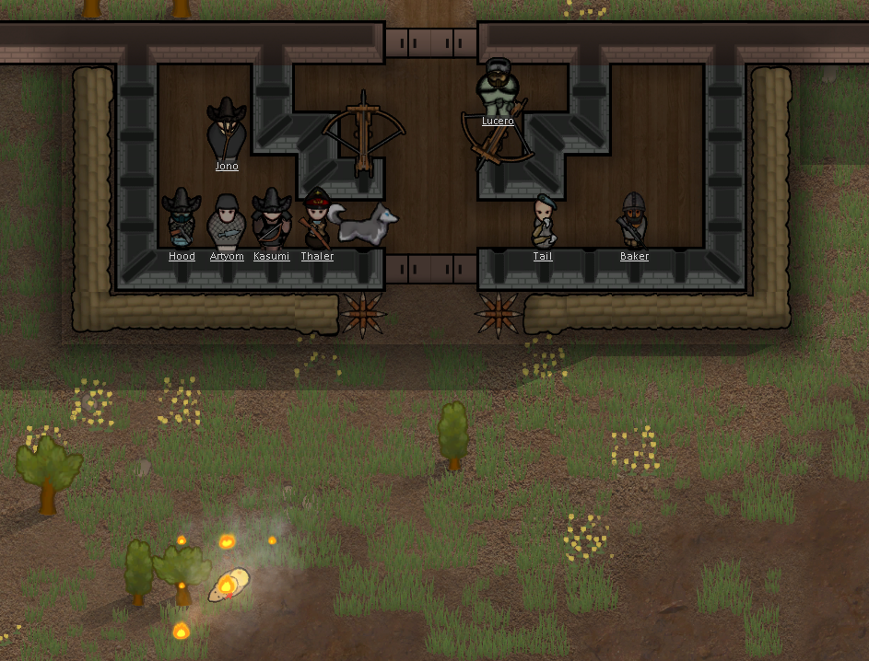

# Day 4

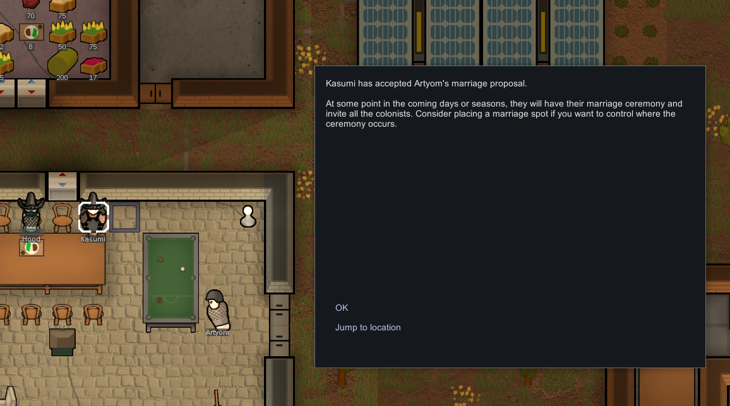

Finally a bit of news that does not have to do with things exploding or catching fire. Kasumi and Artyom are getting married. Artyom is a cool guy but I really don’t like Kasumi, hopefully they are happy together, and it is excuse to have a party.

And just when things were starting to turn up, the other shoe drops. We had a poison ship land a bit outside the base. I have heard it said that these will poison the land until destroyed and are protected by powerful guardians. It is a bit away from the base and we have a decent stockpile of food, so it is not an immediate threat, bit is something I we will need to prepare to deal with.

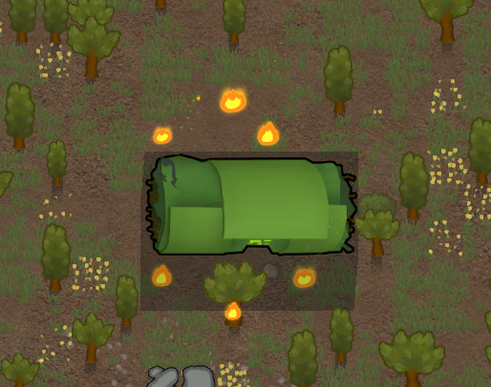

# Day 5

A number of visitors from Threashers River showed up today. Turns out one of them was Hood’s lover Trujillo, it should be nice for them to be able to spend some time together, must be hard living in different colonies. Baker traded some of our Beers for Components, we have enough Beer for now and those components will help when things start breaking down.

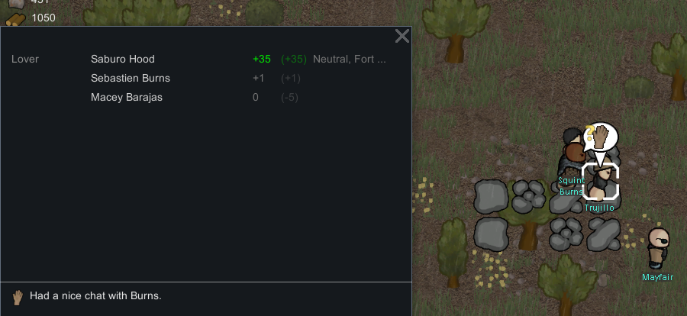

# Day 6

With the Crematorium we managed to dispose of the bodies lying in the field just outside the base, looks a lot nicer now.

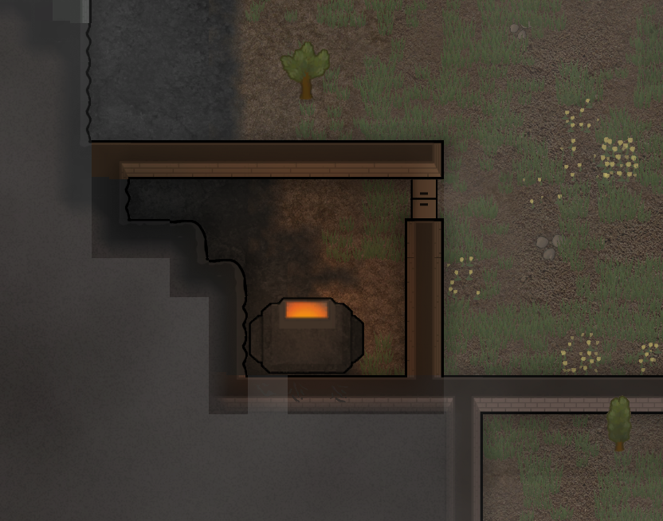

# Day 7

Just put the finishing touches on a new Geothermal Generator, well technically Copeland put the finishing touches, but as leader I organised it. This should stop us running out of power overnight when the wind dies down.

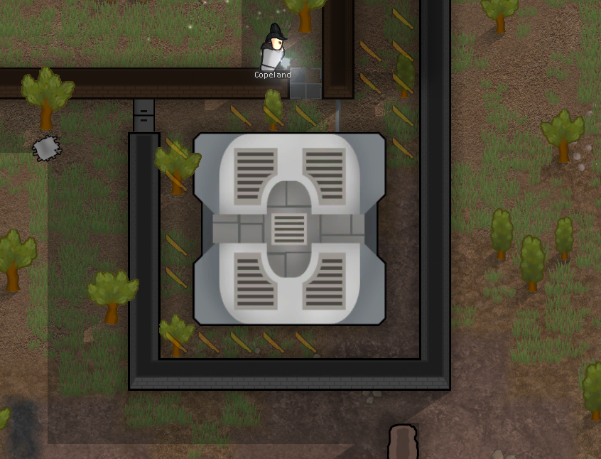

# Day 10

Early morning, up at 5AM and it already 30 degrees C, looks like we are in for a Heat Wave. Hopefully is does not last long, and we have the additional generator to power the coolers, but still not something that I wanted to be dealing with.

A rat went mad and tried attacking the Colony, Copeland and Thaler were able to deal with it.

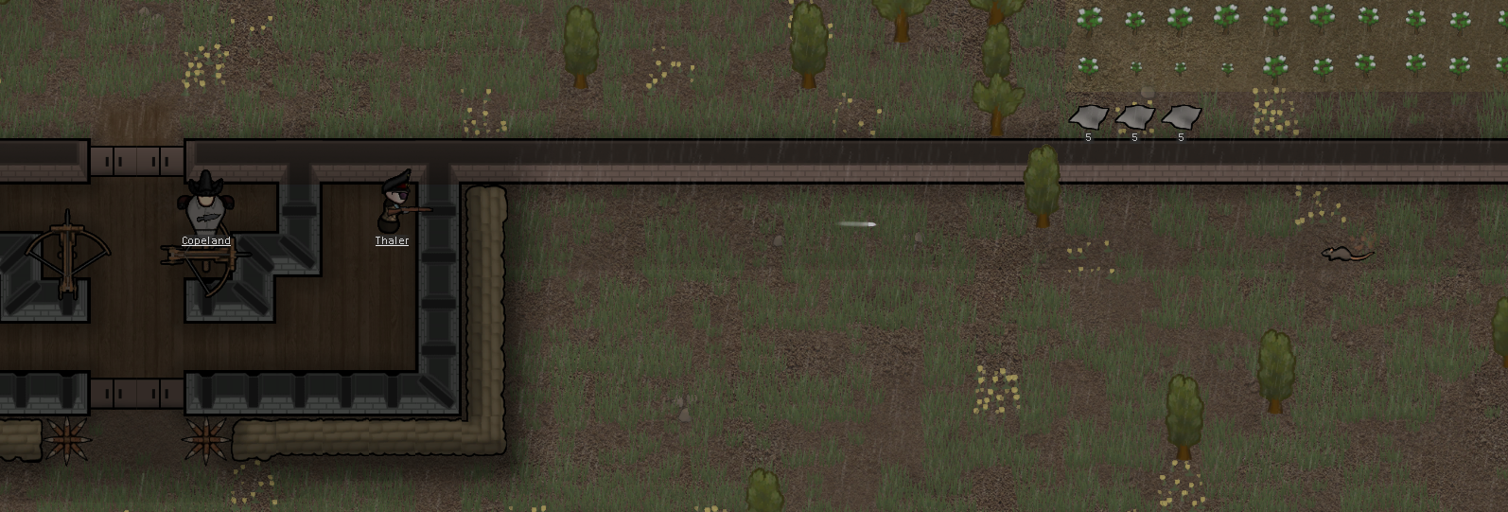

The Research / Crafting room was getting really hot in the Heatwave with the size of it and all the people coming and going through the doors, ended up having Copland install a new cooler, should be much appreciated by Pace and Thaler as they spend a lot of time in there researching.

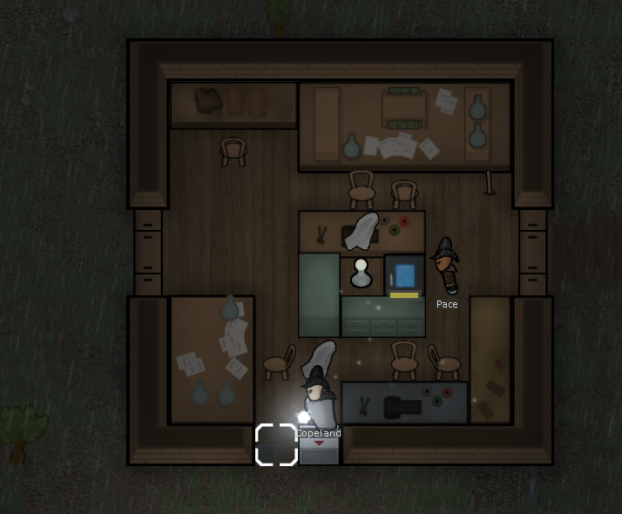

# Day 12

Finally time to deal with that poison ship, Mines have been Researched and placed, the heat wave has passed and we have built fortifications, let’s hope we are ready for whatever comes next. Now to give the order to fire.

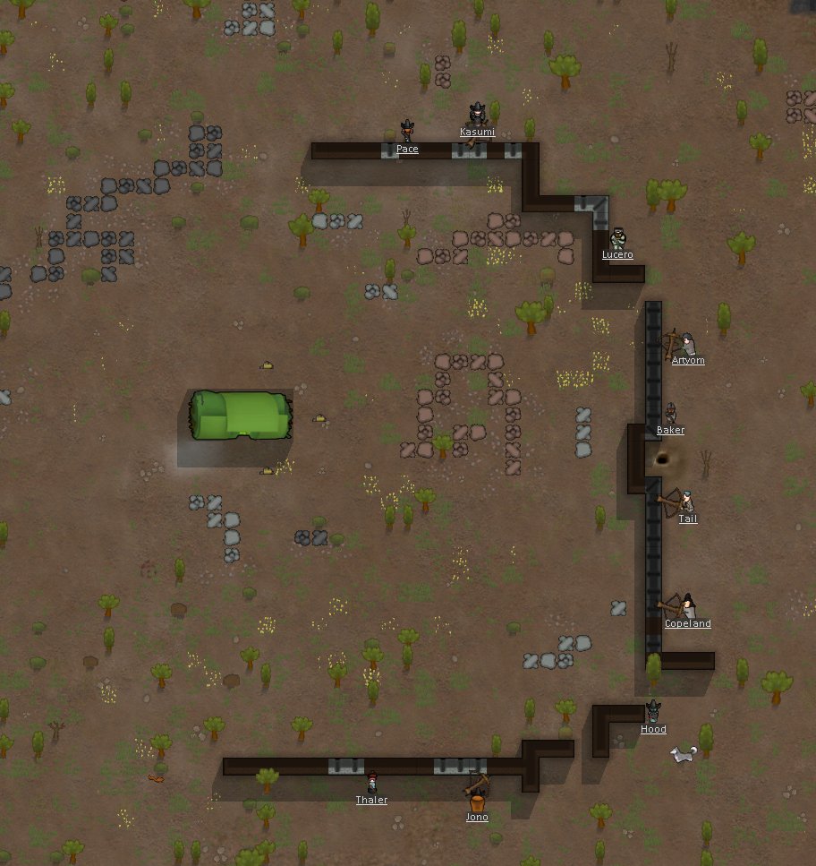

As the Ballista shots flew into the ship 4 Mechanoids burst out defending it. One Centipede with a Heavy charge blaster the other with a Minigun.

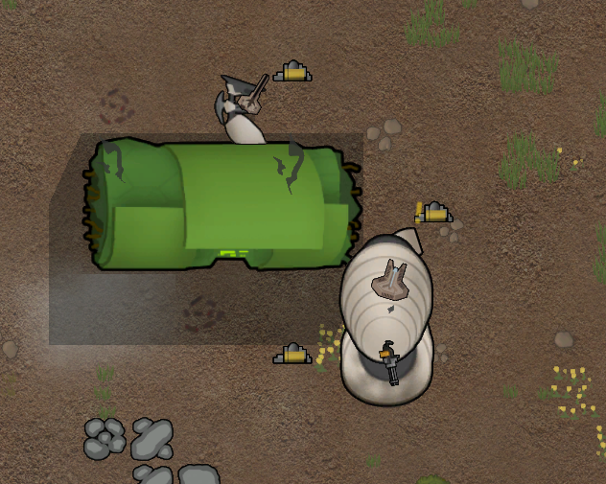

We got luckey and downed a Scyther in the first salvo with a shot to the leg.

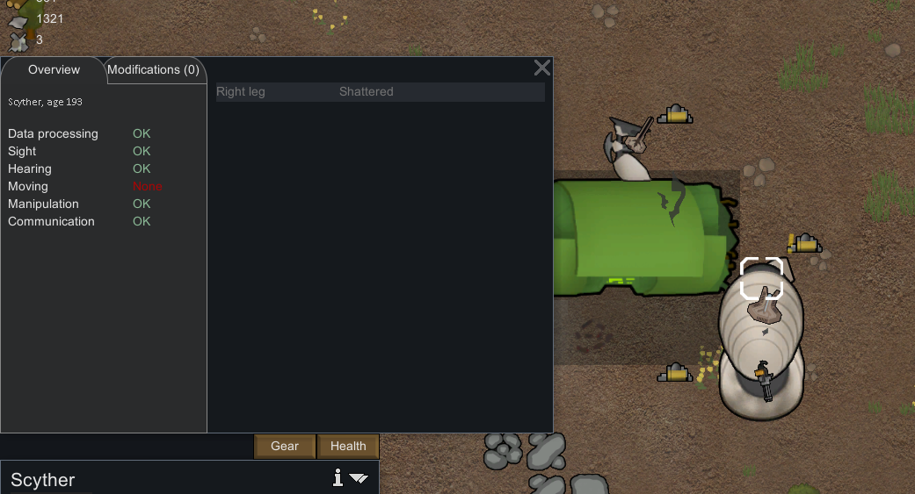

Our First Major injury of the battle, Pace Took a Shot from the Scyher, Maybe it was angry at us Downing the other Scyher, Do Mechanoids feel Anger? Pace screamed out in pain, bleeding badly, but somehow managed to keep fighting.

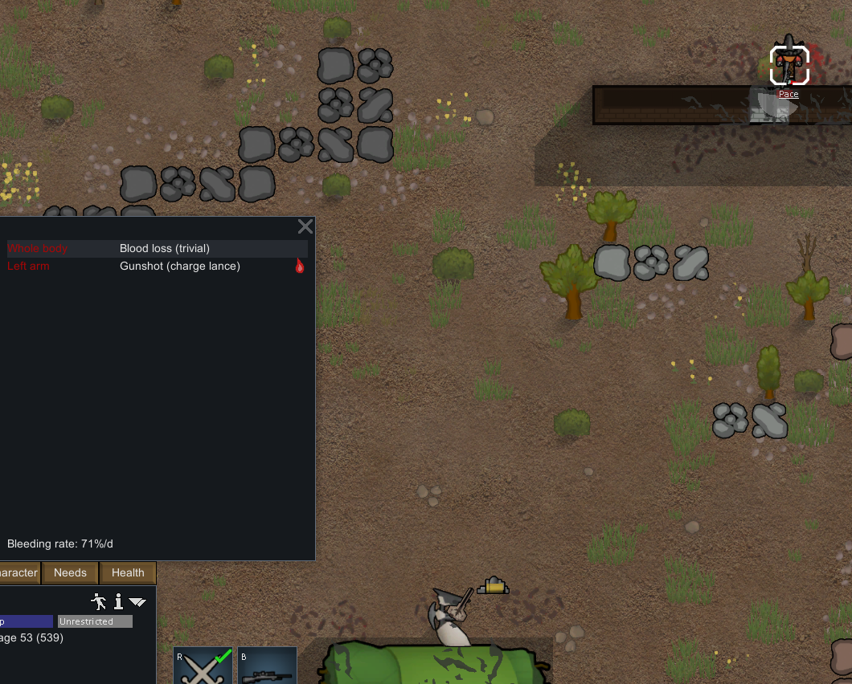

A salvo from the Ballista managed to down the Centipede with the Charge Weapon; these fortifications look to be paying off, half way there.

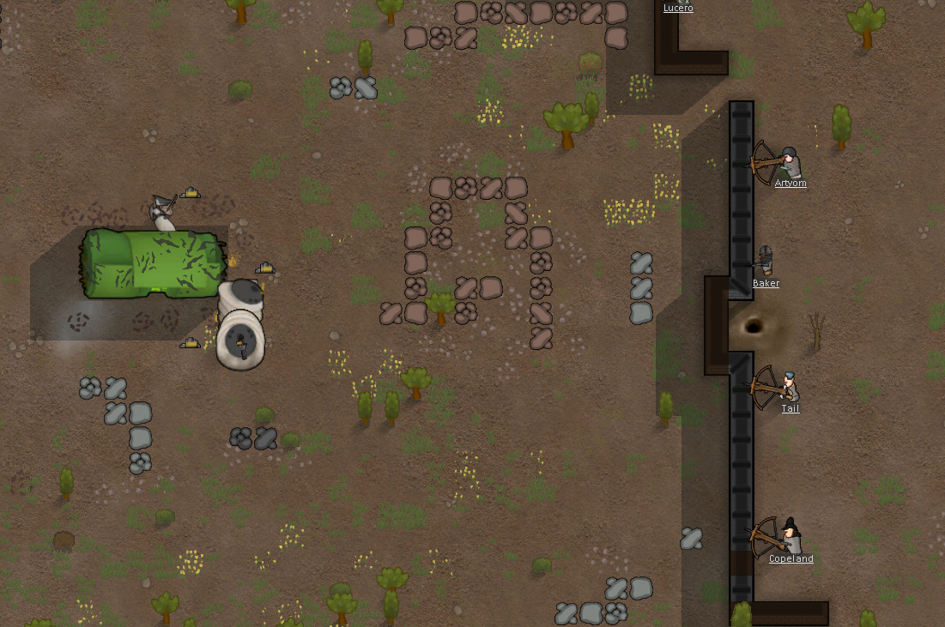

The next Centipede went down in the same way two volleys later. These robots may be tough, but Volleys of Ballista bolts still can do some serious damage to them. This left the single Scyther, the one that had shot Pace and the only one to draw blood from us.

I took it down personally with my Charge Rifle It felt really good to know that the one that had injured us could not hurt anyone anymore.

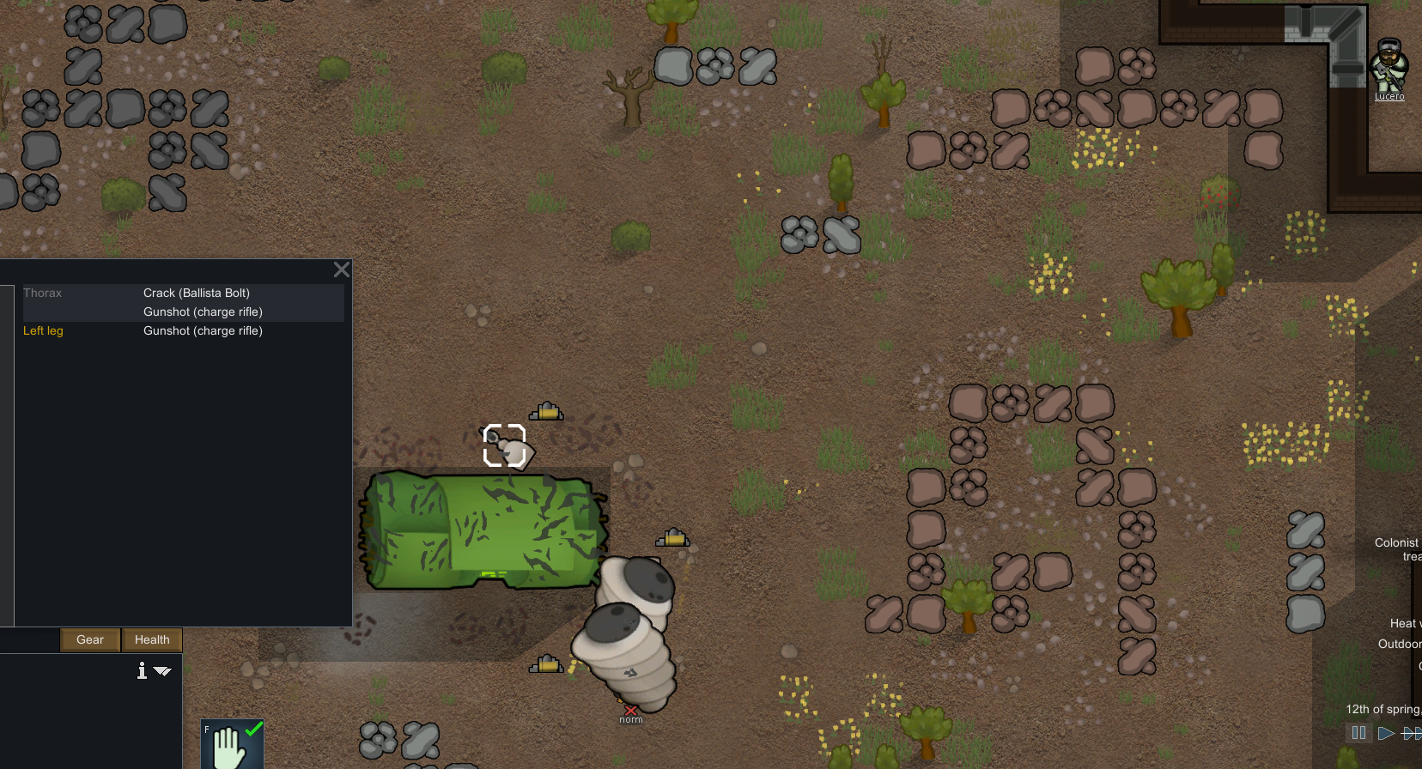

Finally with the immediate threat over I ordered Hood to take Pace back too base to treat her, but she insisted that she could walk despite her injuries and it was not really the time to argue.

The Rest of us remained to finish off the ship itself, but with no guards it should not pose an issue.

Once we took down the ship was down we could all get back to some kind of normalcy. Thaler and Jono set about repairing the defences, although I don’t know that we will need them anymore so they should probably all be torn down. Artyom immediately started eating, after not having time to Eat before the start of the battle I don’t think anyone can blame him. Kasumi set about cleaning up the Paces blood on the ground, I suppose we all deal with a near death experience and watching your best friend getting shot differently.

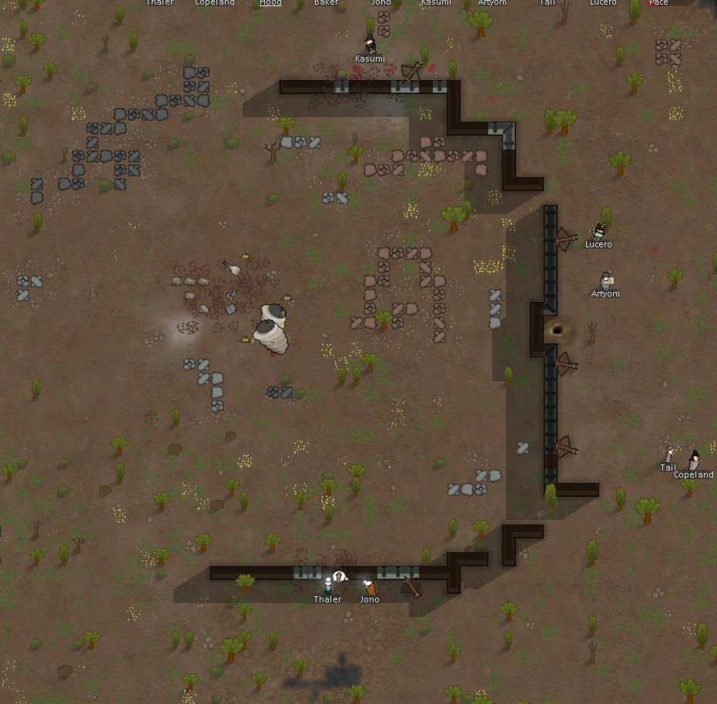

# Day 13

We are trying to get back to a normalcy after our operation to disable the crashed ship. We are Packing up the Ballista and moving them back to base, uninstalling the mines. Don’t know what to do about the walls, we don’t really need the resources right now so I don’t think it is worth the man power right now to remove them.

On a more sombre note Pace has lost her arm, the damage must have been more extensive that I first though. We never really did get along and while she has not said anything about blaming losing the arm, I was in charge and on some level she must blame me, that would only natural. I know I am second guessing all my actions, maybe if I had built more defences, or a forward hospital to get her medical attention sooner… But I can’t keep thinking like that it has been a real experience, going from Prisoner to Leader. It was amazing at first, just getting out of that cell, and being able to order people around, make my new large bedroom. But then things like this happen and you come to realise there is a lot more to leading than just getting to boss everyone around.

I am starting to look forward to only having a few more days until I can go back to just being another girl in the colony without all this pressure.

In an effort to make it up to Pace I have switched the Colonies next research priority to Prosthetics so we can build her a new arm, although It is Ironic that Pace is the one doing the researching, Yeah I think that was irony that time.

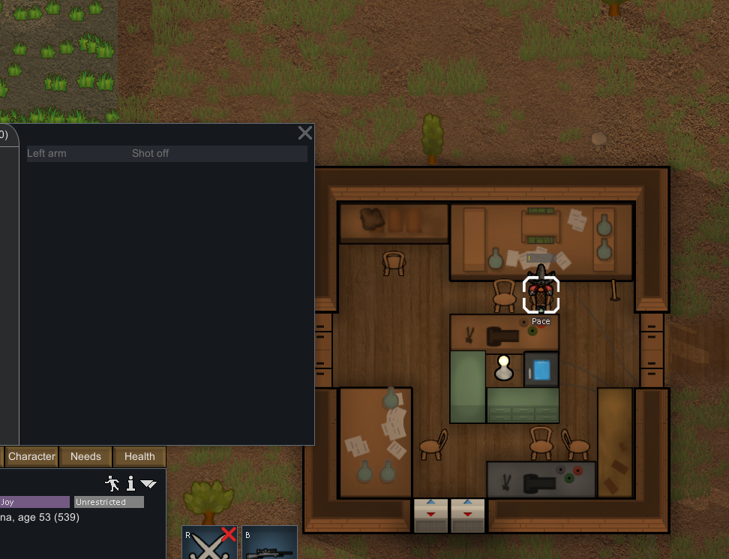

We have had a bunch of Jade drop from the Sky. Maybe I could have it used to make some Artwork for Pace as a sorry for getting your arm blown off present.

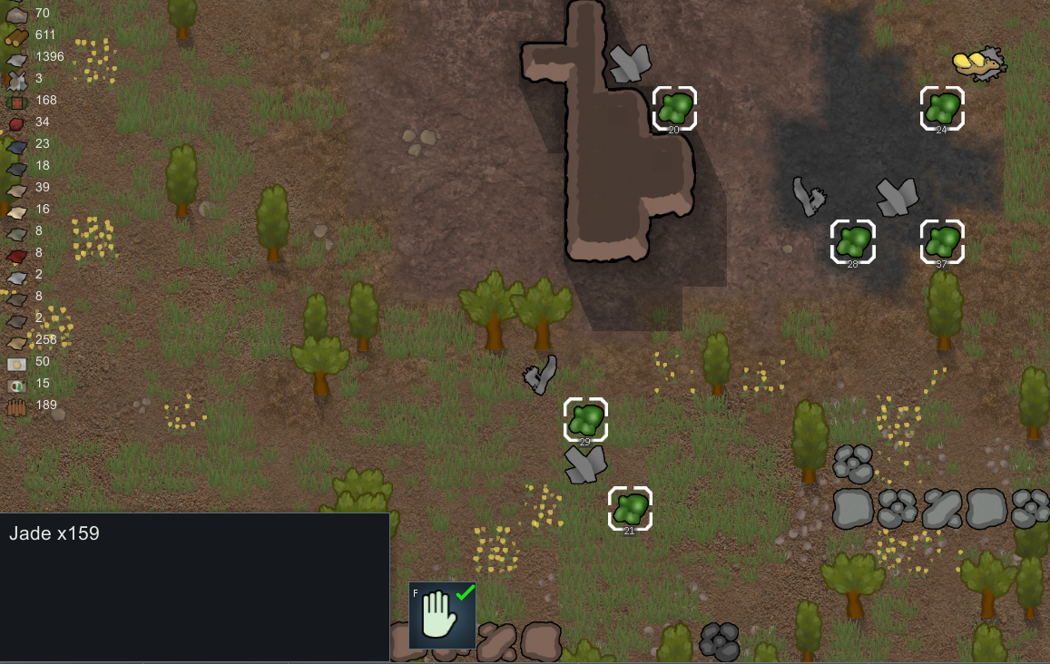

# Day 14

We had some visitors arrive from Threshers River, among them was Engie, Lance Bakers Ex-Wife, hopefully those two do not cause problems.

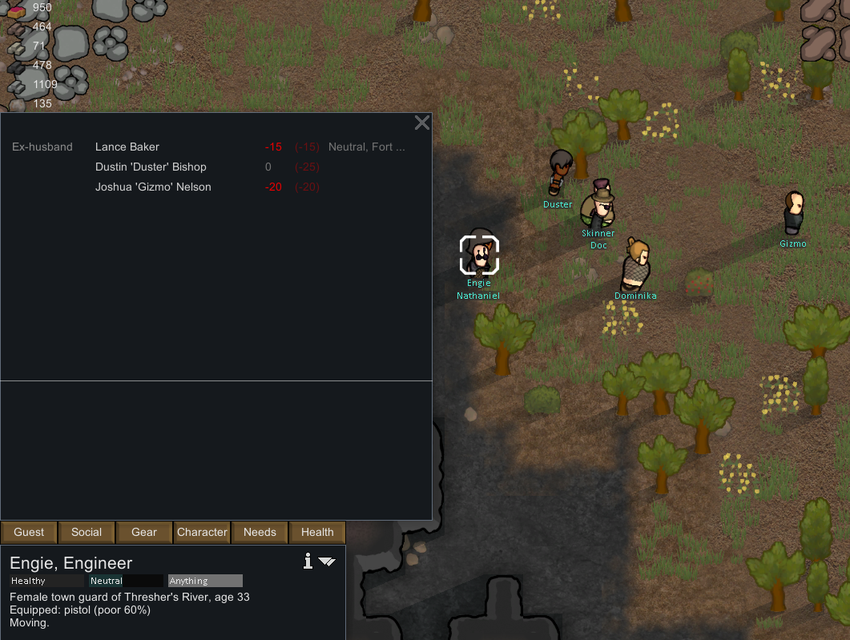

# Day 15

Looks like the Visitors from Threshers River were meeting one of their friends at out Colony. A trader from their faction showed up a day after the rest of them arrived, I wonder if they always intended to meet up here or they just left without him, if so that is not a very nice thing todo, although I guess they must have had their reasons. We traded beer and meals for medicine and components, we both seemed happy with the agreement, although I think he short changed me by 4 silver, not that it really matters.

The main group around 9 am, they must have really enjoyed themselves, they left us 9 Advanced components.

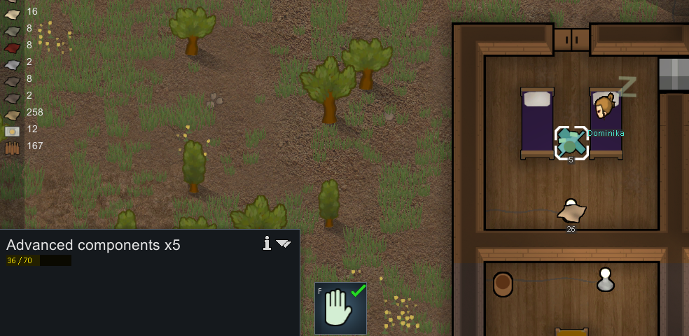

Looks like the group from Threshers River left just a little too soon. Artyom and Kasumi had their wedding ceremony. The whole colony was able to attend, Pace almost slept through it as she is usually up at night, but I went and woke her up after explaining what was happening she was happy to miss out on a little sleep.

We ended up hosting it in the common room, unfortunately we were not able to use the spot that I picked out by the growing fiends because it was too hot out, but in the air conditioning of the common room sitting around drinking beer was a0 thoroughly enjoyable experience all around .

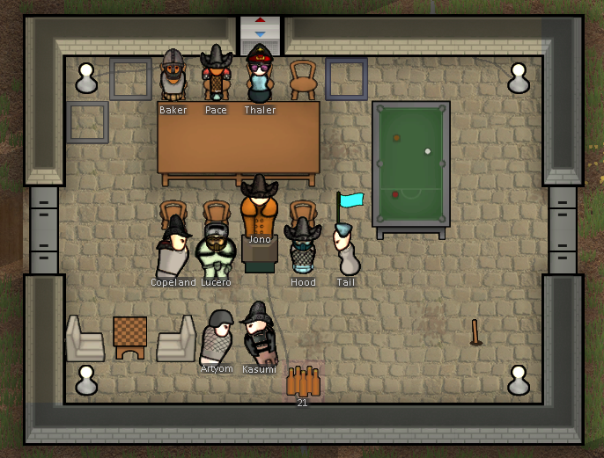

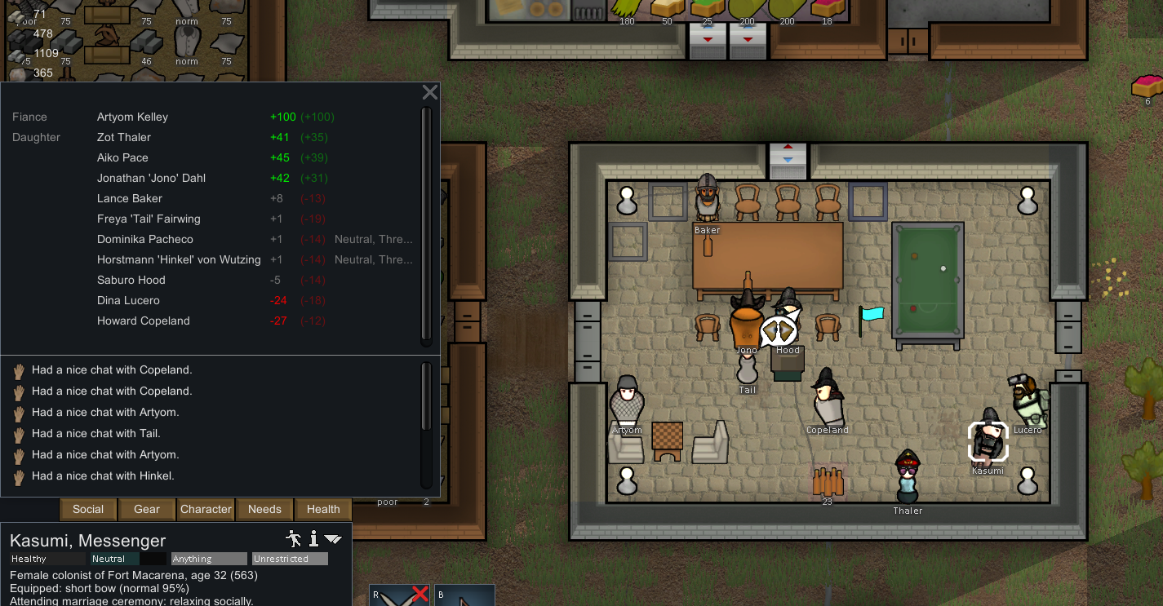

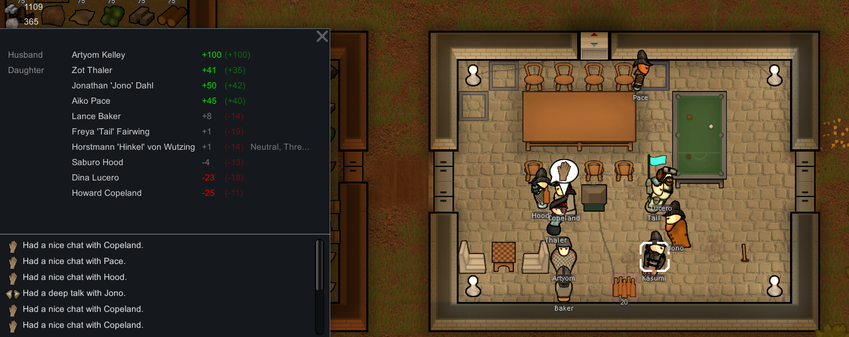

Hinkel the Artist from Threshers River was even able to drop by the ceremony on his way out to catch up with the rest of his group who left earlier in the day.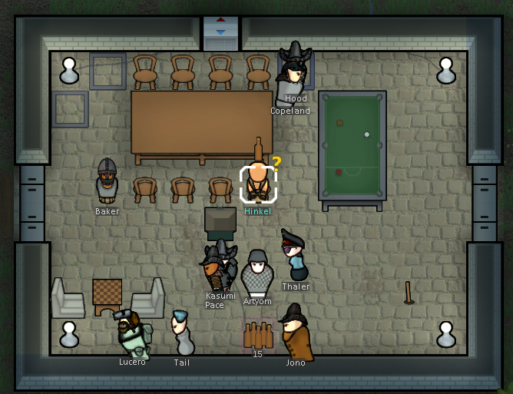

Today was my last day as Leader, Now I am lying in bed, exhausted by all of the ups and downs of this past season, but happy with the job I have done for the colony and all of the fields that I have made, but relieved to not have the pressures of leadership tomorrow.

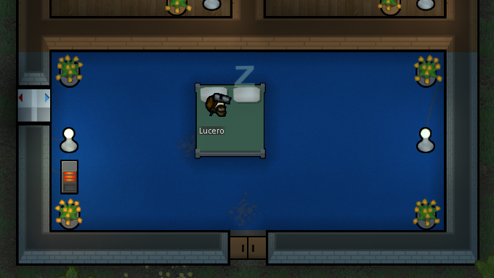

End of Leadership Record for Spring 5501 Fort Macarena, Lucero Recording

